User creation with ORM Stack

Contents

1. Introduction 3
2. Workflow diagram to deploy the stack 3
3. Create stack for User creation 5
4. Plan the Job 7
5. Apply the Job 8
6. Verify in the Console 9
7. Destroy the stack (if required) 11

Introduction

Creates a new user in the tenancy. You must specify a name for the user, which must be unique across all users in tenancy and cannot be changed. Allowed characters: No spaces. Only letters, numerals, hyphens, periods, underscores, +, and @.
This name will be the user's login to the Console. Pick a name that company's own identity system (e.g., Active Directory, LDAP, etc.) already uses.

Workflow diagram to deploy the stack

Below diagram shows how the Terraform Artifact are applied in the OCI. While creating a ORM stack, using terraform deliverables Init, Plan and Apply is the flow to provision the resource in the OCI. We can have the deliverables in any of below.
- GitLab/GitHub Repo
- Bitbucket
- Can be in folder/.zip in the local disk
- Object Storage Bucket
- Can be in compartment
- Oracle provided Template



Create stack for User creation

Go to OCI Console Developer Services Resource Manager Stacks select the compartment Create Stack

My Configuration Folder Browse Select the “Users” folder that contains the artifacts Upload

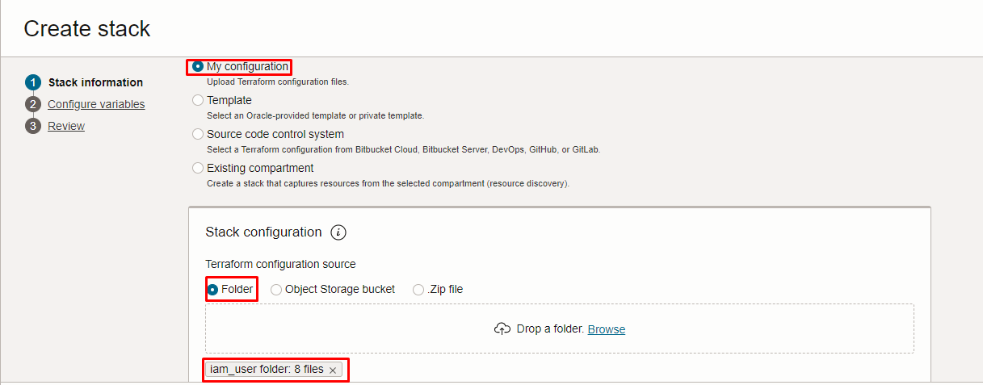

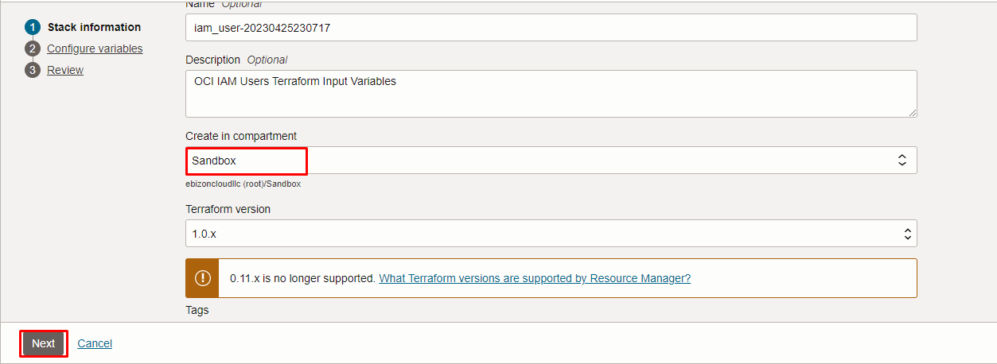

Click “NEXT”

Select the parameters as per the below screen,

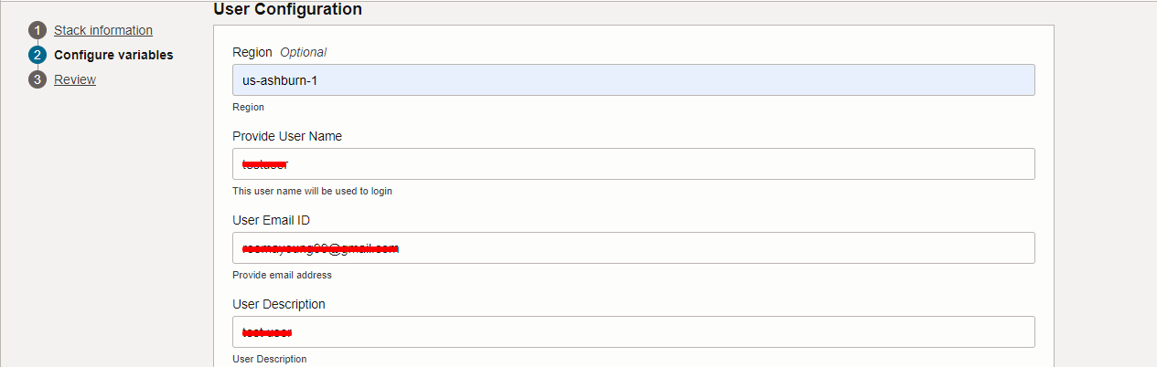

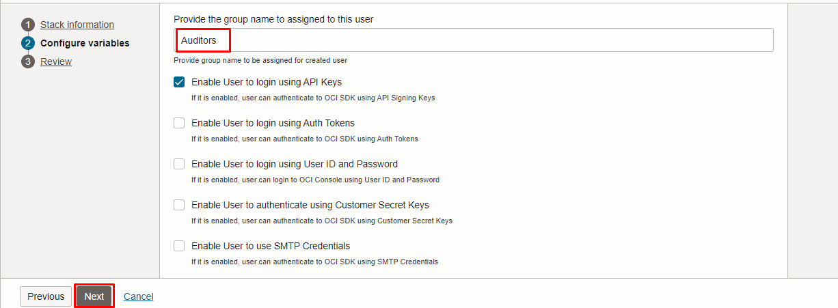
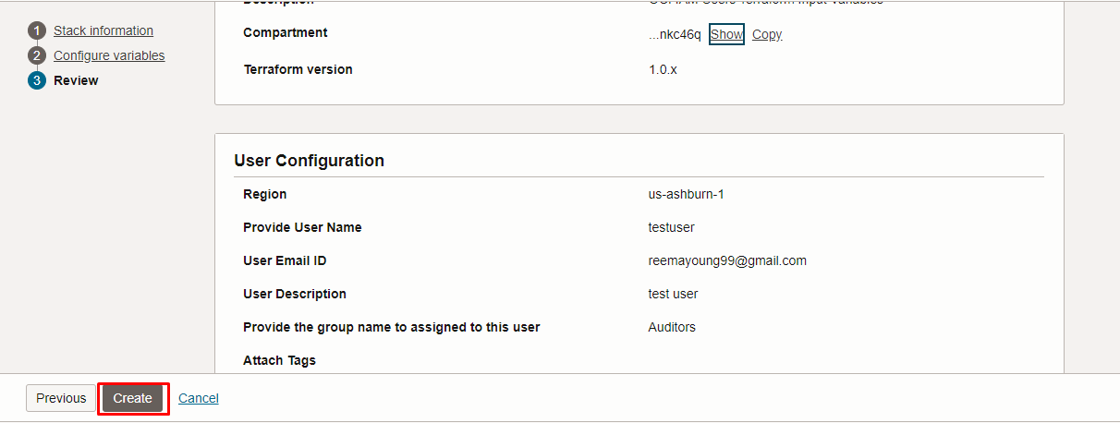

Note: select the right compartment to apply the stack in the OCI

Click “NEXT” Click “CREATE”

Plan the Job

Click the “Plan”
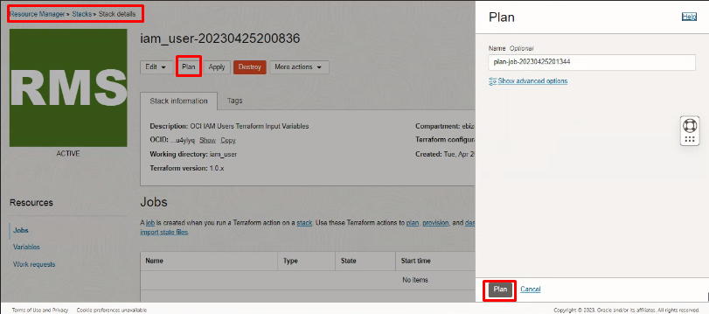

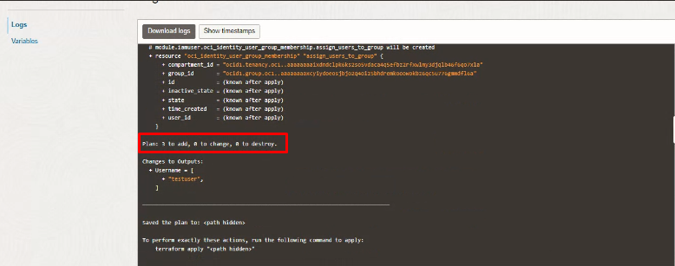

Verify the Plan is successful.

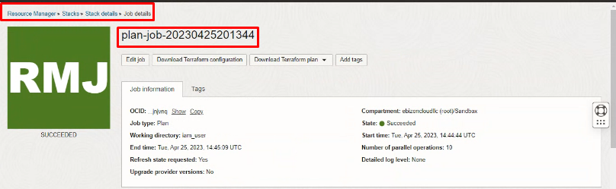

Apply the Job

Once the “plan” is success, now click “Apply”

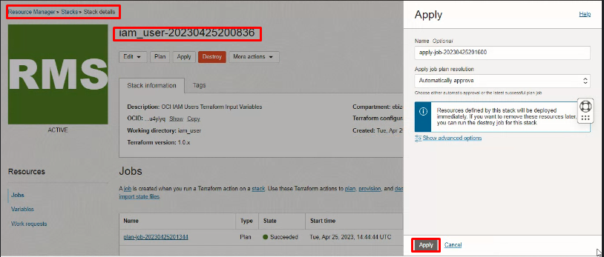

Verify the Apply is successful.

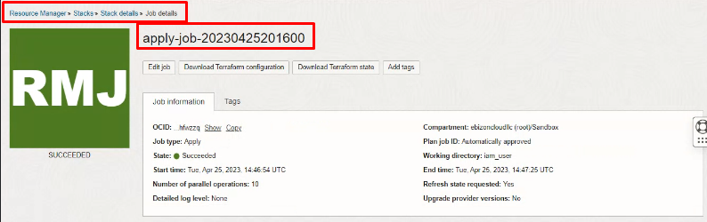

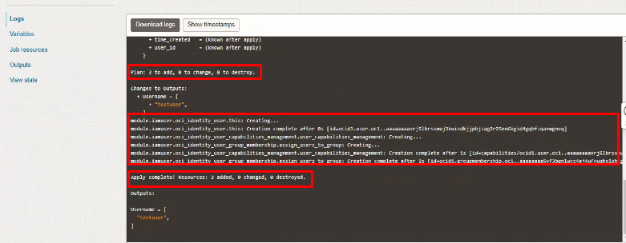

Verify in the Console

Go to OCI Console Identity & Security Domains select the “Default”Domain User

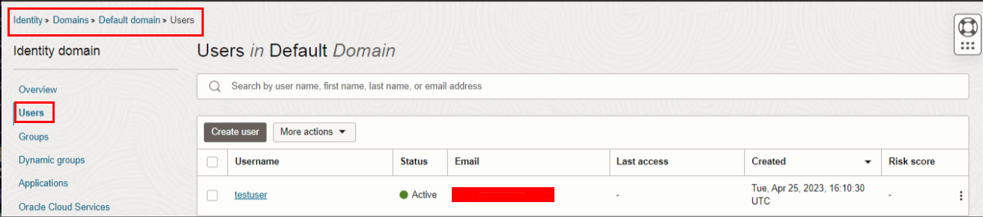

Click the newly created user.
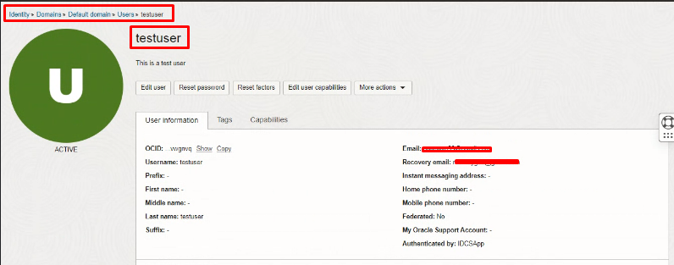

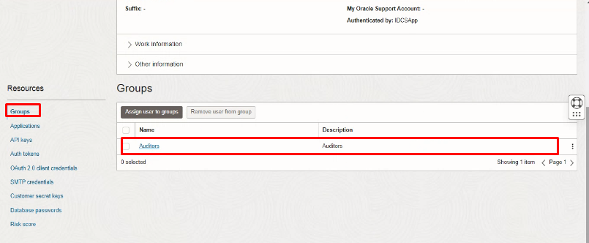

Note: you will receive the below auto-generated email from Oracle.com

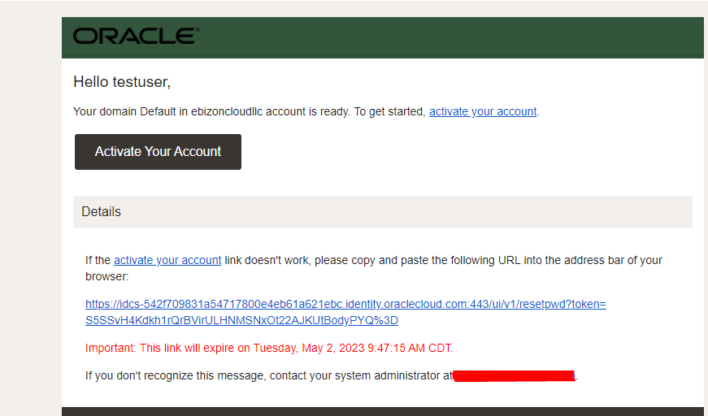

Destroy the stack (if required)

Create a destroy job in Resource Manager to release resources associated with a stack and clean up the tenancy. Once destroyed data cannot be recovered from resources.

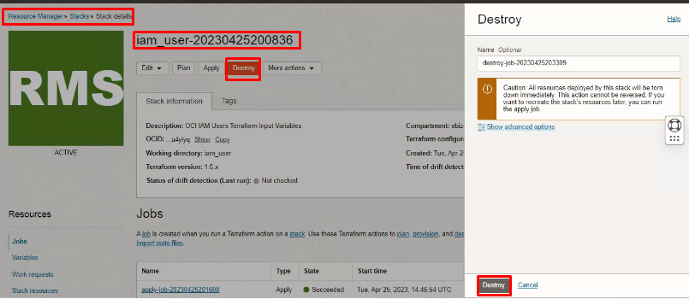

# END #

